PORIKA CHARAN-2303A51570.
LAB 04-4.3

Q.) Advanced Prompt Engineering – Zero-shot, One-shot, and Few-shot
Techniques.
TASK : 01
PROMPT: Generate a Python function that accepts a year as input, checks whether the given year is a leap year using correct logical conditions, and returns an appropriate result. Also include a simple example of input and output.
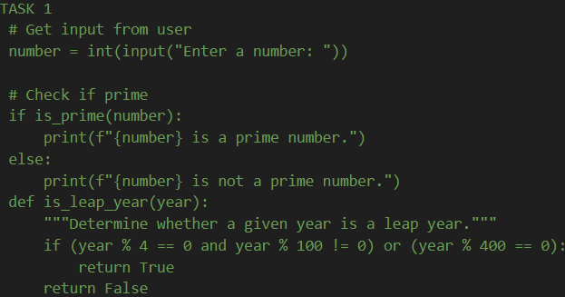
#TASK2
Prompt : generate a Python function that converts centimeters to inches using the correct mathematical formula. The function should accept centimeters as input and return the converted value in inches. Also include a few sample test cases with their outputs.
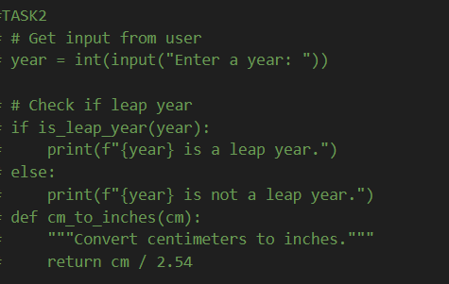
# TASK 3
Prompt: Example 1:
Input: John Smith
Output: Smith, John

Example 2:
Input: Anita Rao
Output: Rao, Anita

Using the above examples, generate a Python function that accepts a full name as input and formats it as "Last, First". The function should correctly handle names following the same pattern. Also include a few sample inputs and outputs.
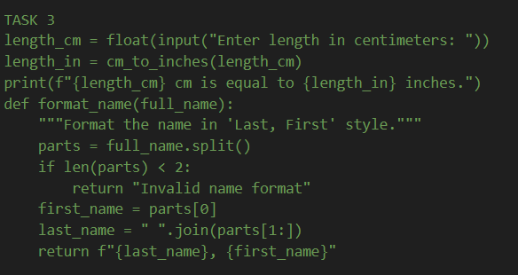
# TASK 4
Prompt: Perform a comparative analysis between Zero-Shot and Few-Shot prompting techniques for Python code generation. Explain how each approach affects code quality, accuracy, clarity, and reliability. Include a brief explanation, a comparison table, and a conclusion highlighting which technique performs better and why.
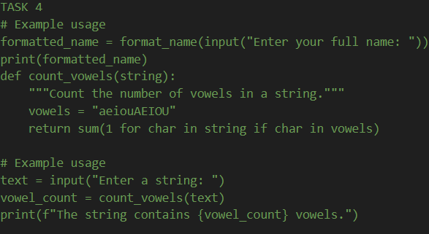
#TASK 5
Prompt: generate a Python function that reads a .txt file, counts the number of lines in the file, and returns the line count. Also include a sample .txt input, output, and a brief explanation of the logic used.
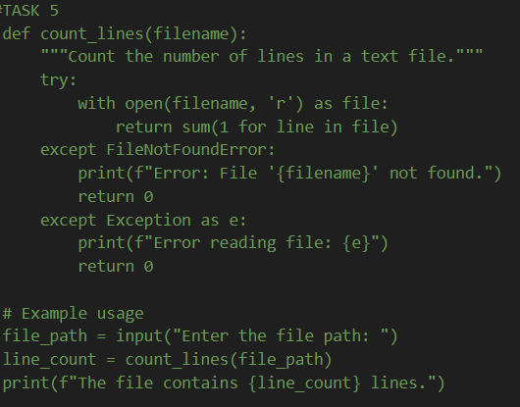s

